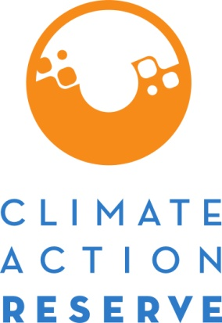

Request for Project Variance
November 2013
The Climate Action Reserve (Reserve) will allow variances in the way specific projects monitor or calculate greenhouse gas emission reductions only where Reserve staff determine that such variances are acceptable and upon submission of this form and payment of the $1,000 fee. No variance request will be considered until the project in question has been formally submitted to the Reserve and all invoices have been paid.
Only with explicit, written acceptance of the variance may a project developer apply monitoring or calculation methods not contained in the Reserve’s applicable protocol for their project. In some cases, a variance request may be granted only for a specified time period. Decisions on variances are to be considered sui generis, and are not precedent-setting. Variances will not be granted for exceptions to project eligibility criteria or to the Reserve’s methodological approaches to determining GHG emission reductions. If the requested variance diverges significantly from the approved methodology in that it requires extensive analysis of site specific features and/or employs concepts not fully vetted through public consultation, the variance must be denied.
The Reserve retains the right to reject outright any Request for Project Variance, request further documentation, or impose additional constraints and/or discount factors on the proposed monitoring or calculation methods.

If the Reserve accepts this variance request, a letter describing the variance granted will be sent to the project developer, and will be made publicly available.
Instructions:
- Upload the Request for Project Variance to the Project Documents section of the project for which the project variance request applies.
- An invoice for the Variance Review Fee ($1,000.00 per request) will be posted in the My Invoices section of your account.
- Pay the Variance Review Fee (instructions for payment are located on the invoice).
- The Request for Project Variance review will commence upon completion of steps 1-3.

Project Details

Date of Request:

Project Developer:

Project Name:

Project Type:

Protocol Version Used:

Reporting Period (for which request applies to):

Form Completed By (name and email):

Requested Variance

- Protocol rule/requirement in question (include page number and quoted text):

- Proposed variance:

- Reason why the project does not meet the rule/requirement listed above:

- Conservative, compensatory measures (e.g., discount factors) taken to counteract variance:

- Justification for why variance results in equal or greater conservativeness than protocol:

