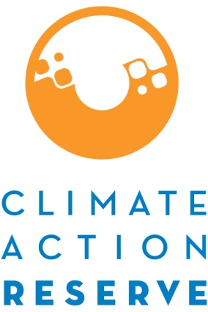
2010 CLIMATE ACTION RESERVE ACCOUNT HOLDER SURVEY RESULTS
The Climate Action Reserve is a private nonprofit organization that works to ensure environmental benefit, integrity and transparency in the carbon market. The Reserve invited all account holders to provide feedback on our program through an Account Holder Survey released in September 2010. The following information provides overall findings from the survey. Responses indicate high satisfaction levels and benefits to participation. The responses also help identify areas for improvement, and the Reserve will use the valued feedback provided to continue to improve its program.

Key findings
- 95.2% of account holders are satisfied with the Climate Action Reserve in general
- 85.7% of account holders find it very important for state or federal government to support voluntary GHG emissions reductions framework like that of the Reserve
-The three biggest challenges to developing a project are:
1. Costs of project development
2. Understanding the protocols
3. Costs of verification

What motivates account holders to participate in the Reserve?
To generate income | 75.0%
To prepare for mandatory regulation | 45.8%
To demonstrate environmental leadership to our stakeholders and the public | 41.7%
To receive recognition for voluntary participation | 16.7%
To receive technical guidance on how to reduce GHG emissions | 16.7%

Account holders ranked the following benefits received
from the Climate Action Reserve
As a result of this survey, Reserve staff will be developing action items and timelines to address recommendations that were identified by account holders. The Reserve will host a webinar and/or public event to share this information.

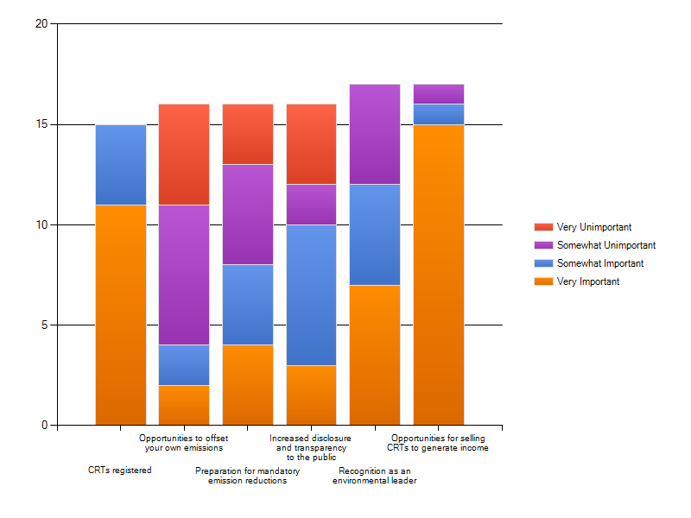
Number of responses
About 10% of all account holders participated in the survey.

