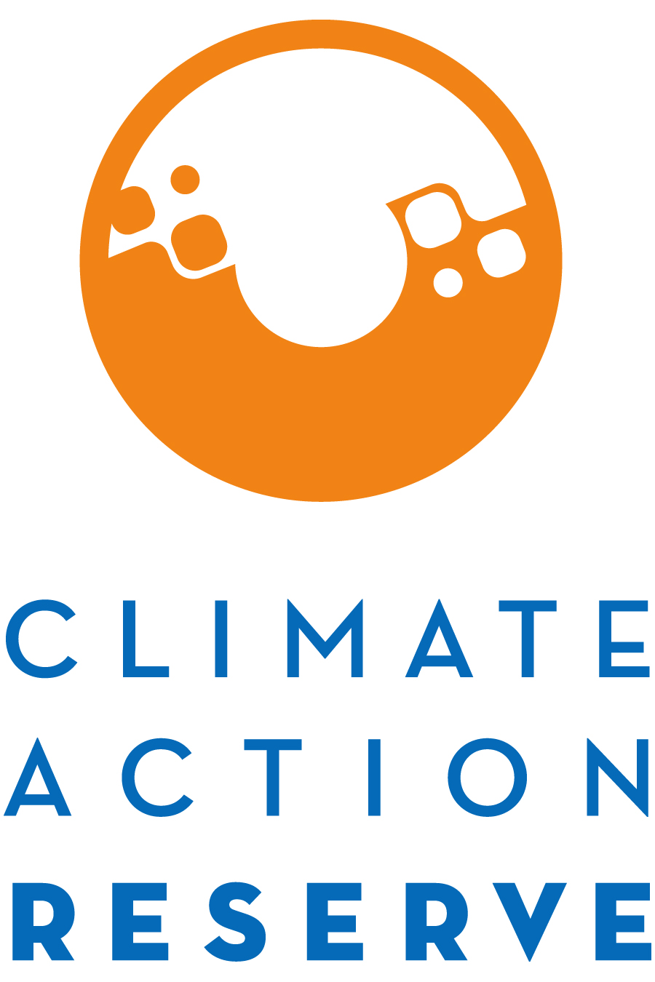

Solicitation of Interested Stakeholders for Participation in Ontario and Québec’s Carbon Offset Protocol Adaptation Process

Dear Interested Stakeholder,

The Ministry of the Environment and Climate Change (MOECC) of the Province of Ontario, along with the Province of Québec, is working with the Climate Action Reserve (Reserve), and the Reserve’s Canadian partners – Brightspot Climate, Cap-Op Energy, EcoRessources, Green Analytics, and Viresco Solutions – to adapt several carbon offset protocols for consideration under Ontario’s and Québec’s cap-and-trade programs. We are soliciting interest from experts and stakeholders for participation in the adaptation process.

Stakeholders will be engaged to provide technical expertise and advice throughout the adaptation time period, commenting on draft versions of the adapted protocol(s), and participating in three or more conference calls or webinars to discuss the protocol(s) and adaptation process.

The protocol adaptation process requires a varying time commitment, depending on which protocols you are interested in providing expertise. All adaptation processes will begin as soon as possible, with various starting and completion deadlines in 2017. Three protocols are estimated to be completed by March/April 2017 (landfill gas capture, ODS destruction, mine methane capture), three protocols by August/September 2017 (conservation cropping, anaerobic digestion (organic waste and manure), efficient refrigeration systems), and the rest of the protocols by December 2017 (forest, afforestation and reforestation, fertilizer management, avoided grassland conversion, emission reductions from livestock (enteric), organic waste management, urban forest). You may indicate interest in multiple protocols, but the Reserve may or may not assign you to the development process for all of them, subject to approval by Ontario and Québec, so please explain in the space provided if your expertise is stronger in one area than another.

If you would like to be involved in the protocol adaptation efforts, please fill out the form below, where you will express your interest and demonstrate your expertise, and email it to policy@climateactionreserve.org.

Thank you for your interest. If you have any questions, please contact the Climate Action Reserve at the above email address.

Ontario and Québec Carbon Offset Protocol Adaptation
Stakeholder Statement of Interest

Name:
Title:
Organization:
Email:
Phone:
Address:

(Please answer all questions in English.)

Are you (or your organization) based in Canada? Yes No
If yes, please mark the province/territory in which you are based:

Ontario | Quebec
Alberta | British Columbia
Manitoba | New Brunswick
Newfoundland and Labrador | Northwest Territories
Nova Scotia | Nunavut
Prince Edward Island | Saskatchewan
Yukon

Please indicate your interest in specific protocols below (select all that apply):
Landfill Gas Capture and Destruction
Mine Methane Capture and Destruction
Ozone Depleting Substances Capture and Destruction
N₂O Reductions from Fertilizer Management
Emission Reductions from Livestock (Enteric)
Anaerobic Digestion (Organic Waste and Manure)
Organic Waste Management
Forest
Afforestation and Reforestation
Urban Forest
Grassland
Conservation Cropping
Refrigeration Systems

Areas of Expertise (select all that apply):
Animal agriculture
Appliance collection and recycling
Carbon offset project development
Carbon offset project verification
Carbon offset protocol/methodology development
Coal mining and mine methane
Crop agriculture
Emissions monitoring and/or metering
Engineering or scientific specialty
Type:
Forest mensuration
Government policy/regulation
Grassland and/or rangeland management
Greenhouse gas accounting
Knowledge of forest land tenure/legal issues
Waste management and diversion
Other relevant area
Please specify:

For each of the protocols selected above, briefly explain why you would like to participate and how the process would benefit from your participation. Include relevant experience and expertise.

Specifically, explain your level of expertise and relevant experience with the sector in which this protocol / project type is relevant (i.e. forestry experience for the forest protocol(s)). Please highlight your Canada-specific expertise, particularly any expertise in Ontario- and/or Québec-specific applications.

Explain your level of expertise and relevant experience with GHG accounting in Canada and/or in the U.S. (Please note, while knowledge of GHG accounting is helpful, it is not a requirement for all stakeholders.)

Please describe, to the best of your knowledge and belief, whether you (or your employer) have any real or perceived conflict of interest with respect to performance of the work contemplated. This should include, but not be limited to: whether you or your organization could benefit financially from the buying and selling of offset credits, or whether you or your organization is likely to be materially involved in the development of an offset project using the protocol(s) that you are nominating yourself to work on. (Note: disclosing a conflict of interest does not exclude individuals or companies from the process, but must be disclosed up front.)

How many hours per week can you commit to this process? hours/week

Do you have any recommendations for other individuals who might be interested in participating in this process? Please feel free to forward this form to colleagues and other stakeholders.

