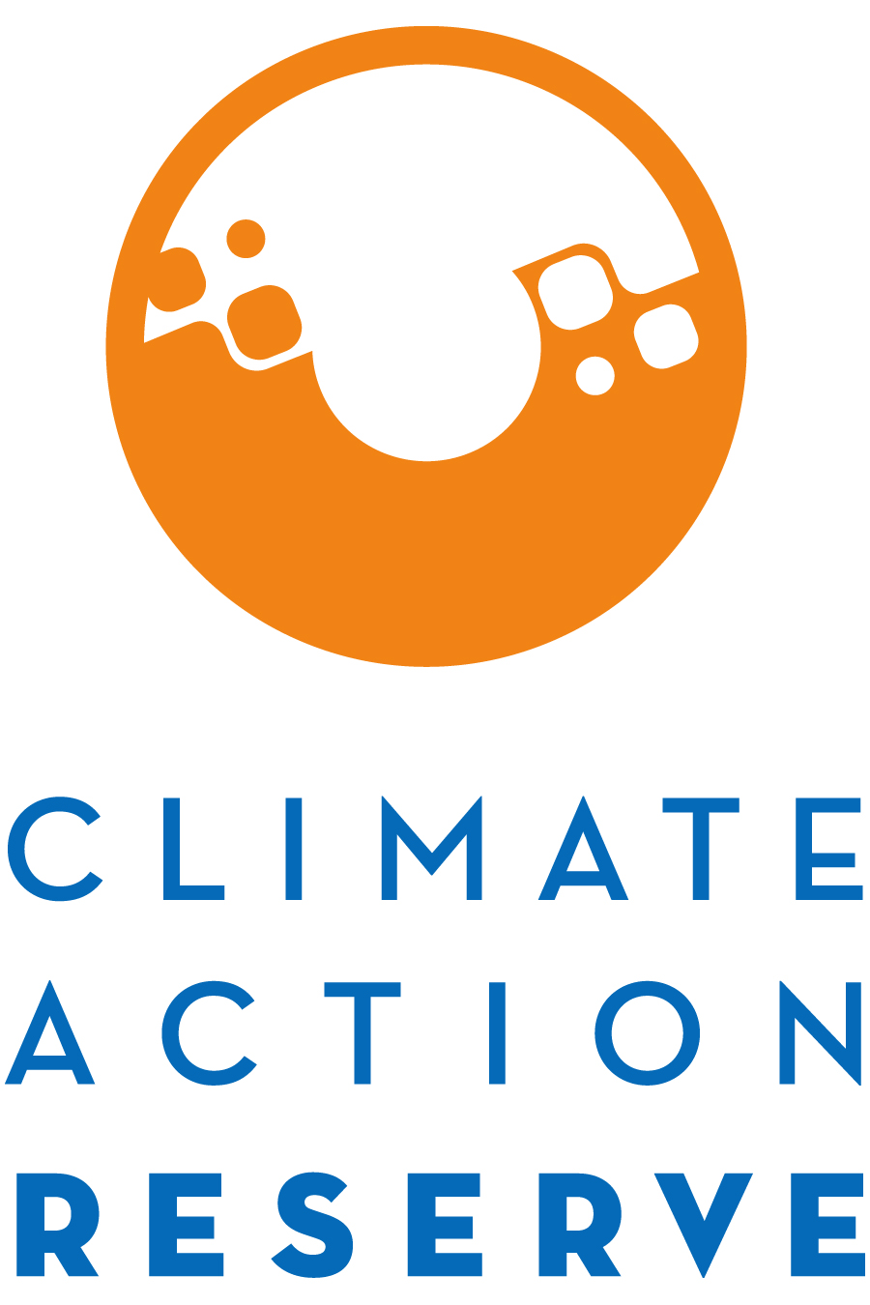

Participation in the Nitrogen Management Project Protocol Workgroup

May 2017

Dear Interested Stakeholder,

The Climate Action Reserve (Reserve) is kicking off the revision process for the Nitrogen Management Project Protocol and soliciting interest in protocol workgroup participation. The revision of the protocol will follow the Reserve’s transparent, stakeholder-driven process, with hopes that the revised protocol will be presented to the Reserve Board of Directors in October. Your involvement in this process will be a critical component of our success.

You are invited to participate in this process by completing the attached form, where you will express your interest and demonstrate your expertise to be part of the protocol workgroup.

The workgroup requires a moderate time commitment, an advanced understanding of GHG accounting, and a masterful understanding of specific agriculture processes and practices related to nutrient management. The Reserve plans to have workgroup meetings once a month this summer, all of which will be accessible via webinar, with the third and final meeting also being held in-person, when we will discuss a complete draft protocol. The workgroup members are responsible for helping to develop, comment on, and test the revised sections of the protocol, in addition to submitting written comments on both the draft protocol and final protocol.

Because of the technical nature of the work and a desire to reach consensus-based decisions, the protocol workgroup must be limited in size. We will strive to create a well-balanced workgroup with representation from industry, government, project developers, academia, verifiers, and environmental advocacy organizations across the United States.

Please email the completed form to policy@climateactionreserve.org in order to be considered for the workgroup. If you are not chosen to be a workgroup participant, we urge you to participate in the process by submitting written comments on the protocol when it is available and attending the public webinar we will host during the public comment period.

Thank you for your interest. If you have any questions, please feel free to contact the Policy Team at policy@climateactionreserve.org.

Nitrogen Management Project Protocol
Stakeholder Statement of Interest

Areas of expertise (select all that apply):
Agricultural land management
GHG accounting
GHG project development
GHG/Environmental markets
GHG modeling
Academic research
Environmental advocacy
Other (please specify)

Name:
Title:
Organization:
Email:
Phone:
Address:

What has been your involvement with the Nitrogen Management Project Protocol and/or other agricultural offset protocols to date:
☐ NMPP V1.0 workgroup member
☐ Other agricultural protocol workgroup member. Please specify:
☐ C-AGG member
☐ CIG partner
☐ Methodology developer
☐ Project developer
☐ Aggregator
☐ Other (please specify):

Briefly explain why you would like to participate as a workgroup member for the Nitrogen Management Project Protocol. Justify why you should be included and how the process would benefit from your participation. Include relevant experience and expertise.

Specifically, explain your level of expertise and relevant experience with agriculture practices and technologies related to GHG mitigation and nutrient management.

Specifically, explain your level of expertise and relevant experience with GHG accounting and carbon offset projects.

How many hours per week can you commit to the workgroup process?
hours/week

