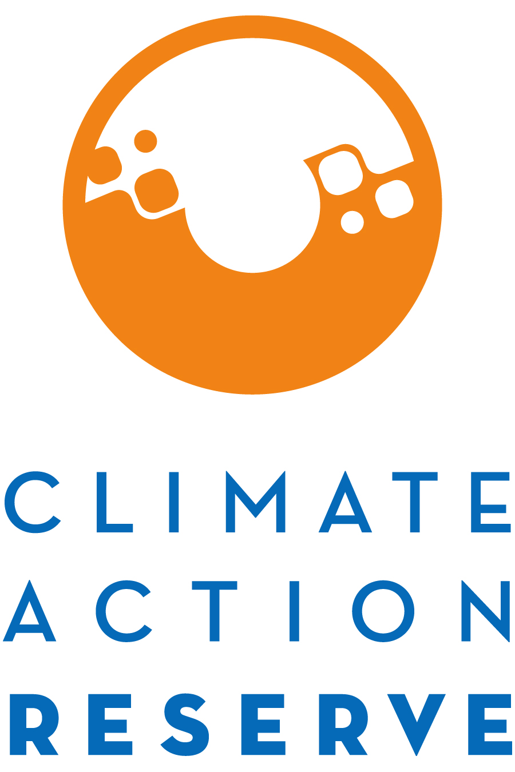
Invitation to Participate in the Expert Stakeholder Workgroup for the U.S. Landfill Project Protocol

Dear Interested Stakeholder,

The Climate Action Reserve (Reserve) is considering revisions to the U.S. Landfill Project Protocol. The protocol update will include a reassessment of the Version 4.0 Performance Standard Test, while also incorporating previously released errata and clarifications, update language and protocol guidance concerning reporting periods, verification periods, crediting periods, and QA/QC.

This project protocol will be revised through the Reserve’s transparent, stakeholder-driven process. Your involvement in this process will be a critical component of our success. For such an update, the Reserve would normally re-engage with the original protocol workgroup during the revision process. However, since the original workgroup was formed more than 10 years ago, and the last major protocol revision was adopted in 2011, we have decided to re-open the workgroup application process for this new update.

You are invited to participate in this process by completing the attached form, where you will express your interest and demonstrate your expertise to be part of the protocol workgroup.

The workgroup requires a significant time commitment, an advanced understanding of GHG accounting, and an understanding of landfill gas collection and destruction systems. The workgroup members are responsible for helping to develop and comment on draft versions and sections of the protocol, in addition to submitting written comments on the final protocol. Below is a summarized timeline of the development process.

Activity | Timing
Public Scoping Meeting (webinar) | October 10, 2018
Convene Workgroup (WG) & Staff Begins Update Analysis | October 2018
1st WG Meeting (Webinar) | Early November 2018
Staff Begins Drafting – Working with WG | November 2018
2nd WG Meeting (Webinar) to Review Draft | Late December 2018 – early January 2019
Staff Revises Draft – Incorporating WG Feedback | January 2019
Public Comment Period | January – February 2019
Public Comment Meeting (Webinar) | February 2019
Staff Revises Draft – Incorporating Public Feedback | February – March 2019
Final Protocol Adoption by Reserve Board | April 2019

Because of the technical nature of the work and a desire to reach consensus-based decisions, the protocol workgroup must be limited in size. We will strive to create a well-balanced workgroup with representation from industry, government, carbon and energy project developers, academia, verifiers, and environmental advocacy organizations.

If you are not chosen to be a workgroup participant, we urge you to participate in the process by submitting written comments on the protocol when it is available next year and attending the public workshop we will host during the public comment period.

Thank you for your interest. If you have any questions, please contact the Policy Team at policy@climateactionreserve.org or 213-542-0282.

U.S. Landfill Project Protocol Workgroup Statement of Interest

Areas of expertise (select all that apply):
Landfill gas systems
Landfill regulations
GHG accounting
GHG project development
GHG/Environmental markets
Environmental advocacy
Academic research
Other (please specify)

Name:
Title:
Organization:
Email:
Phone:
Address:

Briefly explain why you would like to participate as a workgroup member for the Landfill Project Protocol.

Justify why you should be included in the workgroup and how the process would benefit from your participation. Include relevant experience and expertise.

Specifically, explain your level of expertise and relevant experience with landfills and landfill gas destruction technologies.

How many hours per week can you commit to this process from October 2018 – April 2019?
hours/week

