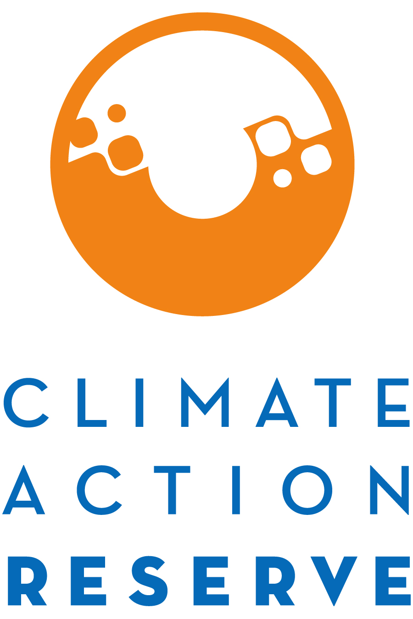

Invitation to Participate in the Adipic Acid Production Project Protocol Development Process

August 15, 2019

The Climate Action Reserve (Reserve) is developing a greenhouse gas (GHG) project protocol for the reduction of N₂O at adipic acid production facilities. The Adipic Acid Production Project Protocol will provide a standardized approach for quantifying and monitoring the GHG reductions from projects that destroy N₂O emissions from adipic acid plants.

This project protocol will be developed through the Reserve’s transparent, stakeholder-driven process. Your involvement in this process will be a critical component of our success.

You are invited to participate in this process by completing the attached form, where you will express your interest and demonstrate your expertise to be part of the protocol workgroup.

The workgroup requires a significant time commitment, an advanced understanding of GHG accounting, and a comprehensive understanding of adipic acid production and N₂O decomposition facilities. The workgroup members are responsible for helping to develop, comment on, and test early versions and sections of the protocol over the next few months, in addition to submitting written comments on both the workgroup draft protocol (October 2019) and public draft protocol (November 2019).

Because of the technical nature of the work and a desire to reach consensus-based decisions, the protocol workgroup must be limited in size. We will strive to create a well-balanced workgroup with representation from industry, government, project developers, academia, verifiers, and environmental advocacy organizations.

Please email the completed form to policy@climateactionreserve.org by Friday, September 20, 2019 in order to be considered for the workgroup.

If you are not chosen to be a workgroup participant, we urge you to participate in the process as an “observer” by attending workgroup meetings in listen-only mode, submitting written comments on the protocol when it is available for public comment in November, and attending the public webinar we will host during the public comment period.

Thank you for your interest. If you have any questions, please feel free to contact Trevor Anderson at tanderson@climateactionreserve.org or 213-891-6927.

Adipic Acid Production Project Protocol Stakeholder Statement of Interest
Areas of expertise (select all that apply):

Greenhouse gas accounting
Adipic acid industry
N₂O abatement
NO_{x} abatement
Catalytic/thermal decomposition
Other (please specify)

Current sector:

Project proponent/developer
Verifier
Carbon broker
Industry consultant
Government
Adipic acid industry
NGO
Environmental group
Other (please specify)

Name:
Title:
Organization:
Email:
Phone:
Address:

How many hours per week can you commit to this process from September – December 2019?
hours/week

How is your organization involved with adipic acid plants?

What technical skills/experience could you offer to the workgroup process?

What regulatory and policy experience in the realm of N₂O or NO_{x} abatement at adipic acid plants could you offer to the workgroup process?

Briefly explain why you would like to participate as a workgroup member for the Adipic Acid Production Project Protocol.

Justify why you should be included in the workgroup and how the process would benefit from your participation. Include relevant experience and expertise.

