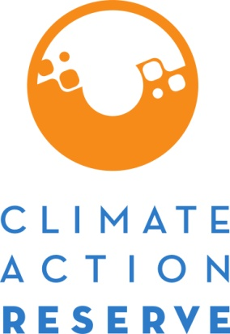
Request for Project Registration Extension
March 2015
The Climate Action Reserve (Reserve) may grant an extension to a project’s initial registration deadline upon submission of this form and payment of a $200 fee. The registration deadline for non-forest projects is twelve (12) months after the end of the initial reporting period, and the deadline for forest and urban forest projects is thirty (30) months after the project is submitted. No extension request will be granted unless the project has commenced verification and has undergone a site visit for the reporting period and all outstanding invoices for the project and account holder have been paid. The following extensions may be granted:

- Forest and Urban Forest projects may be granted a twelve (12) month extension.
- US Livestock and US Ozone Depleting Substances projects may be granted a six (6) month extension.
- All other project types may be granted a 30 day extension if the account holder can demonstrate to the Reserve’s satisfaction that they will miss the deadline due to extraordinary circumstances. The Reserve holds the right to determine what rises to the level of an extraordinary circumstance.

Only with explicit, written approval of the request may an account holder submit a project for registration after the initial registration deadline has passed. The Reserve retains the right to (1) reject any Request for Project Registration Extension that does not comply with these requirements, (2) request further documentation, and/or (3) impose additional constraints. If the Reserve accepts this extension request, a letter stating the new project registration deadline will be sent to the account holder, and will be made publicly available. A maximum of one extension may be granted per project. Extension requests must be received prior to the project’s initial registration deadline. If denied or received after this registration deadline, the project must be re-submitted for registration under the most current version of its associated protocol.

Instructions
- Complete the Request for Project Registration Extension form and email the completed form and requested documentation to reserve@climateactionreserve.org
- An invoice for the review fee ($200 per request) will be emailed directly to you.
- Pay the review fee (instructions for payment are located on the invoice).
- The review will commence upon completion of steps 1-3.

Project Details

Date of Request:

Account Holder:

Project Number (e.g. CAR100):

Project Type:

Protocol Version Used:

Reporting Period (for which request applies to): to

Form Completed By (name and email):

- Has a site visit occurred? Yes, Date(s): No

- Reason for Extension: provide a detailed description of any issues that are contributing to the delay in meeting the deadline.

- Provide documentation to confirm a site visit for the project has occurred (e.g. List of Findings reflecting site visit activity, draft Verification Report, plane tickets, travel receipts, etc.).

