Guidance for Transitioning Early Action Projects to the California Air Resources Board’s Compliance Offset Protocol U.S. Forest Projects

March 19, 2015

Table of Contents

1. Introduction 3

2. Important Transition Timelines 3

2.1. Converting Early Action Offset Program credits to ARB offset credits 3

2.2. Transitioning Early Action Offset Projects to ARB’s Compliance Offset Program: 4

3. Transition Date 4

4. Transitioning Early Action Forest Project Protocol Version 2.1 Conservation-Based Forest Management and 3.0, 3.1 & 3.2 Improved Forest Management Projects 5

4.1. High Stocking Reference 6

4.1.1. Determining the HSR 7

4.1.2. Determining the effect of the HSR on the project’s baseline 9

4.2. Development of a Representative Commencement Date Inventory 11

4.3. Develop a Compliance Protocol Baseline 12

4.4. Calculate the Credits Eligible under the Protocol 13

5. Transitioning Early Action Forest Project Protocol Version 3.x Reforestation Projects 14

6. Transitioning Early Action Forest Project Protocol Version 3.x Avoided Conversion Projects 15

# Introduction

Section 95990(k) of the Cap-and-Trade Regulation (Regulation) allows for the transition of early action offset projects to the applicable Compliance Offset Protocol (COP). The Regulation contains programmatic and quantification requirements that projects must adhere to in order to be eligible for transition to the COP. This document provides guidance for transitioning early action offset projects developed under the Climate Action Reserve’s (CAR) Forest Project Protocol Versions 2.1, 3.0, 3.1 and 3.2.

The act of transitioning to the COP is the point that project crediting shifts from crediting greenhouse gas (GHG) emission reductions and removal enhancements under the early action offset protocol to crediting GHG emission reductions and removal enhancements under the COP.

# Important Transition Timelines

Transition timelines are applicable to all early action offset protocol versions and projects seeking to transition to the compliance offset program.

The following are important dates for converting credits issued by an Early Action Offset Program (EAOP) to ARB offset credits and transitioning early action offset projects to the compliance offset program. These dates are:

## Converting Early Action Offset Program credits to ARB offset credits[1]

* Offset Project Operators (OPOs) who wish to be issued early action offset credits and eventually convert those credits to ARB offset credits must have listed their projects with an EAOP by **January 1, 2014**. 17 CCR § 95990(c)(3)(A).[2]
* Early action offset projects were able to continue to operate under approved early action quantification methodology until **December 31, 2014**. 17 CCR §§ 95990(c)(1) and (h)(2).
* To be issued ARB offset credits, all early action offset projects must complete verification under the EAOP and submit an Offset Verification Statement by **September 30, 2015**. 17 CCR § 95990 (h)(3).
* EAOPs must issue offset credits by **January 1, 2016** for those reporting periods to be eligible for ARB offset credits.
* Projects that have received early action offset credits must list any reporting period for which they wish to have ARB offset credits issued by **January 1, 2016**. 17 CCR § 95990(e)(3).
* The last date that ARB will issue ARB offset credits for early action GHG reductions/removal enhancements achieved through 2014 is **August 31, 2016**. 17 CCR § 95990(k)(5).

## Transitioning Early Action Offset Projects to ARB’s Compliance Offset Program:

An OPO wishing to be issued ARB offset credits for GHG emission reductions or removal enhancements achieved after **December 31, 2014** must have submitted listing information to an Offset Project Registry (OPR) and have had their listing approved by the OPR no later than **February 28, 2015** 17 CCR § 95990(k)(1)(D).

* Once the project begins to operate under the COP:
  + The project must meet all regulatory deadlines under the Cap-and-Trade Program.
  + The OPO must report a minimum of 6 months of offset project data and a maximum of 24 months of data for the initial reporting period.
  + The OPO must submit the initial Offset Project Data Report (OPDR) no later than 24 months from the project’s listing date.
  + The OPDR must be submitted within 4 months after the last day of the reporting period covered by the OPDR.
  + The Offset Verification Statement must be submitted within 11 months after the last day of the reporting period covered by the OPDR.[3]

# Transition Date

The transition date is applicable to all early action offset protocol versions and projects seeking to transition.

The transition date should be the most recent reporting period end date under the early action offset protocol prior to January 1, 2015. The initial reporting period under the COP begins on the day following the end date of the final early action reporting period. There should be no gap in reporting between the reporting periods under the EAOP and the initial reporting period using the COP project.

# Transitioning Early Action Forest Project Protocol Version 2.1 Conservation-Based Forest Management and 3.0, 3.1 & 3.2 Improved Forest Management Projects

The following section describes requirements applicable to transitioning CAR Forest Project Protocol Version 2.1 Conservation-Based Forest Management projects and Version 3.0, 3.1, and 3.2 (hereafter referred to as 3.x) Improved Forest Management (IFM) projects to the compliance offset program.

The COP will establish the basis for determining project crediting following the transition date. All projects developed using CAR Forest Project Protocol Version 2.1 will recalculate the baseline according to the COP back to the early action project’s commencement date. CAR Forest Project Protocol Versions 3.x IFM projects will need to recalculate the baseline according the COP if the COP has a different set of required volume or biomass equations or if it is determined that the High Stocking Reference (HSR) under the COP would influence the early action offset project’s baseline.

Guidance is provided in this document to determine whether versions 3.x IFM projects will need to recalculate the project baseline. Projects that recalculate the baseline according to the COP will have to develop an inventory that is representative of the project area’s carbon stocks as of the early action offset project’s commencement date.

Early action offset projects transitioning to the COP should compare the credits they received under the EAOP to the credits they would have received during the same time period using the COP’s IFM quantification methods.[4]

* If the early action offset project received fewer early action offset credits than would have been received under the COP, the project will be issued the balance accounting for any ARB Forest Buffer Account contributions and other required COP deductions.
* If the early action offset project received early action offset credits greater than or equal to the number of offset credits that would have been received under the COP, all early action offset credits are eligible to transition to ARB offset credits accounting for any ARB Forest Buffer Account contributions and other COP deductions.
* In both cases the project may receive ARB offset credits for increases (growth) in project carbon stocks going forward. Any subsequent increases in carbon stocks will be credited consistent with quantification methods under the COP.

The following sections explain the steps an early action offset project would need to take to recalculate the project’s baseline as required by COP.

## High Stocking Reference

This section is only applicable to CAR Forest Project Protocol Version 3.x Improved Forest Management early action projects (CAR V3.x IFM projects) whose inventories of standing live and dead carbon stocks were below Common Practice (CP) at project commencement date. This section will help the OPO determine if the HSR calculated according to the COP will require the OPO to recalculate its early action offset project’s baseline. Because Version 2.1 projects must consider all requirements in the COP regarding baseline development in order to transition, including HSR, Version 2.1 projects can skip this section and proceed to the ‘Develop a Representative Commencement Date Inventory’ section of this guidance below.

CAR V3.x IFM Early Action projects which had initial carbon stocks (ICS) for aboveground standing live carbon stocks below Common Practice at project commencement must perform an analysis of the carbon inventories that existed prior to original project commencement. To do this, HSR must be determined at the project commencement date. The HSR is a criterion used in the calculation of IFM baselines for projects with ICS below CP. Equation 6.6 of the COP defines the HSR as 80 percent of the highest value for aboveground standing live carbon stocks (AGSLCS) per acre within the Project Area during the preceding 10-year period (Figure 1). To determine the HSR, the OPO or Authorized Project Designee (APD) must document changes in the Project Area’s AGSLCS over the preceding 10 years prior to project commencement, regardless of who owned the carbon stocks within the Project Area during that period. The HSR will only affect the project’s baseline if it exceeds the project’s ICS at the project’s commencement date.

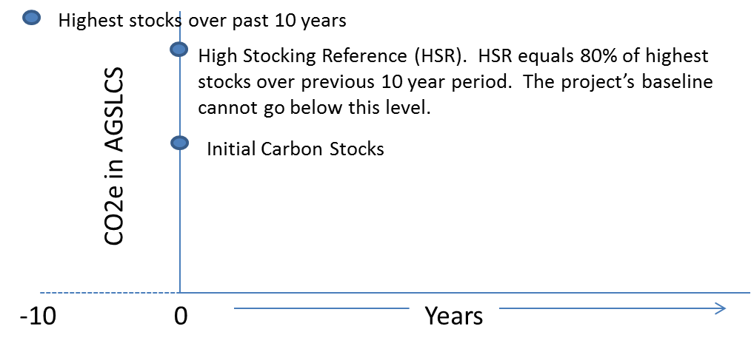

**Figure 1**: HSR is applicable to the minimum baseline level (MBL) because the following two conditions are met: (1) the project’s ICSs are below common practice at project commencement, and (2) the High Stocking Reference is above the project’s ICS at project commencement.

If it is determined the HSR would have affected the baseline determination as of the commencement date, a second test must be applied to determine if the HSR will have an effect on the project’s baseline as of the project’s transition date. If the early action project’s ICS are below CP at project commencement, those projects must apply the COP HSR requirements. Provided below are two recommended methods for determining HSR:

* + - 1. Recalculate the baseline following the HSR requirements, or
      2. Demonstrate that the HSR has no effect on project crediting as of the transition date by calculating the project’s HSR (see Option 1 and 2 below) and then performing a comparison of the HSR to current project data, as discussed below.

### Determining the HSR

**Option 1:** Analysis using Historic Inventory Data  
  
For landowners with inventory data for the property dating back 10 years prior to the early action offset project commencement date, use the same methodology used to calculate the project’s inventory at project commencement and verified during the project’s initial verification to calculate historic AGSLCS per acre. In such cases, the highest historic (10-year period prior to commencement) AGSLCS should be used to calculate the HSR.[5] Note that there is only one project commencement date - that of the original early action project commencement date.

**Option 2:** Analysis using Estimated Inventory Data

* + - * 1. Estimate the project’s tree canopy area (defined as the area of the project under tree canopy cover) at commencement date using the U.S. Forest Service’s iTree Canopy tools (available online). The iTree canopy tools establish random points within a user-defined area. The user will attribute the random points to generate an estimate of the percent canopy within the project boundaries. Confidence of the percent canopy estimate should meet or exceed ±10% at one standard error. Use the percent canopy to estimate the square feet of canopy area within the project area.
        2. Develop a metric ton CO2e per square foot of canopy area value by dividing the project’s metric tons CO2e estimate for the total AGSLCS from commencement date inventory data by the project’s canopy area estimate at commencement date from step 1.
        3. Estimate the project’s historical tree canopy for several points in time up to 10 years, using several points spanning the 10 years (with at least one point between 8-10 years) prior to the early action offset project’s commencement date by importing the same points generated in Step 1 by the iTree Canopy tool into Google maps where historical images can be queried. Attribute the points using the scheme in step 1 to generate historic estimates of the historical percent canopy. Use the historical percent canopy to estimate the historical square feet of canopy area within the project area.
        4. Apply the metric ton CO2e/ square foot value from step 2 to the historic canopy area estimate from step 3 to develop an historical estimate of the metric tons CO2e in total AGSLCS for the pre-commencement year.
        5. Repeat steps 3 and 4 for other historical time points.
        6. Calculate the HSR using the highest historical stocking estimate.

### Determining the effect of the HSR on the project’s baseline

There are three potential scenarios that may arise from the analysis of the HSR.

**Scenario 1**

The HSR is equal to, or less than, the estimate of the project’s AGSLCS at the project’s commencement date (figure 2). In this case, the HSR will not affect the updated baseline calculated as part of the transition to the COP. The OPO/APD will need to provide documentation outlining the analysis as part of the transitioning process.

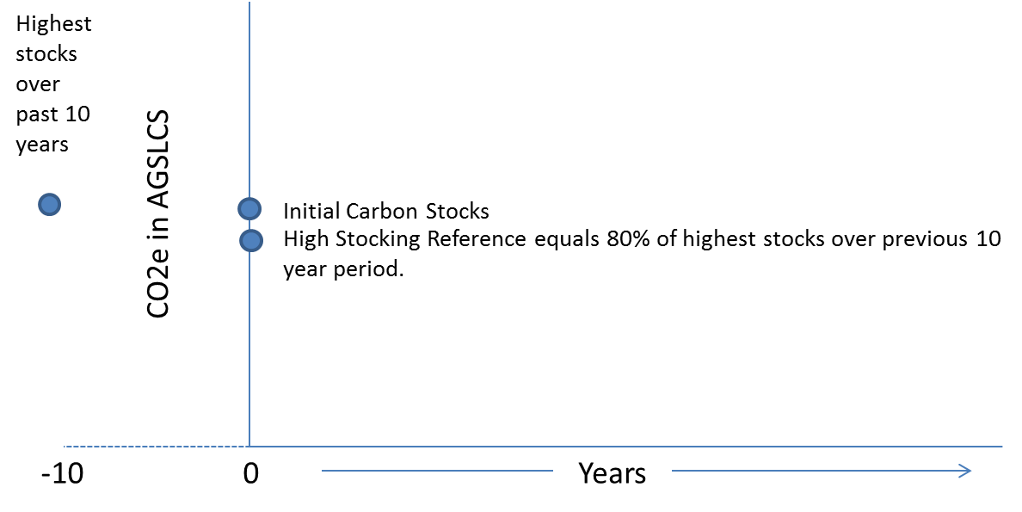

**Figure 2**: HSR does not affect baseline at transition if ICS < CP and HSR ≤ AGSLCS at project commencement date.

**Scenario 2**

The HSR is equal to, or less than, the estimate of the project’s AGSLCS as of the project’s transition date (Figure 3). In this case, the HSR will not affect the updated baseline calculated as part of the transition to the COP. The OPO/APD will need to provide documentation outlining the analysis as part of the transitioning process.

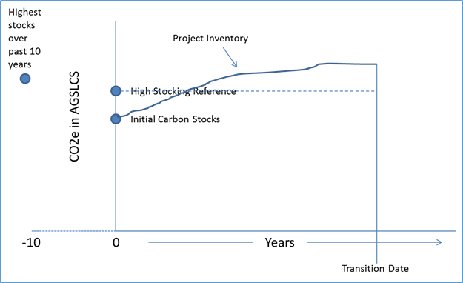

**Figure 3**. HSR does not affect baseline at transition if ICS < CP and HSR ≤ AGSLCS at transition date.

**Scenario 3**

If the HSR exceeds the estimate of the project’s AGSLCS as of the transition date, then the project operator must include the HSR in updating the project’s baseline to meet the standards under the COP. No ARB offset credits can be issued under the COP until the project’s inventory of AGSLCS exceeds the updated baseline.

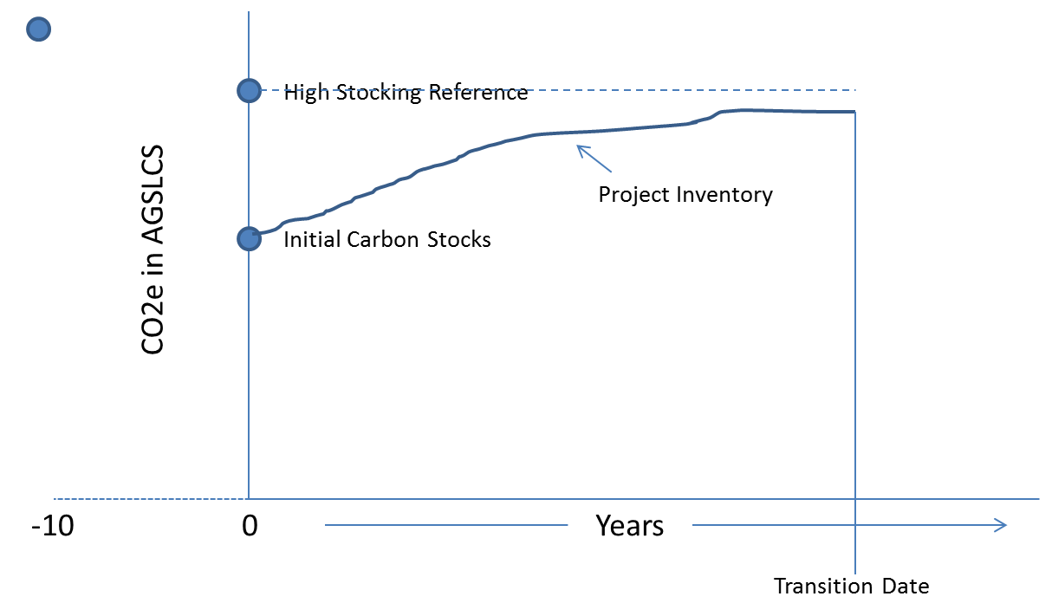

**Figure 4**. The project baseline must be updated if ICS < CP, and the HSR > AGSLCD at transition date.

## Development of a Representative Commencement Date Inventory

This section of the guidance is applicable to all CAR Forest Project Protocol Version 2.1 Conservation –Based Forest Management projects and CAR Forest Project Protocol Version 3.x IFM projects with initial stocks below common practice.

The transitioning project should develop a current inventory estimate that complies with the requirements of the COP, including the use of volume models and biomass equations adopted with the COP.[6] This inventory will be verified according to the verification requirements in the COP as part of the transition. The COP requires that the inventory be based on the above and belowground portions of standing live and dead trees.[7] The COP does not allow other carbon pools such as soil carbon and lying dead wood.[8] The intent of the process described here is to develop a representative project commencement date inventory.

The current inventory can be ‘backcast’ to the project’s commencement date, such that the backcast inventory represents the project’s stocks on the early action offset project commencement date. Early action offset projects that have inventory data at the project commencement date that is compliant with the quantification requirements in the COP can forego this step. Verifiers will examine the inventory data to ensure it meets the COP requirements. Backcasting the inventory should be accomplished using the following steps (see table 1 for example):

1. Grow the inventory tree lists from the current inventory data forward (e.g., 5 or 10 years) using an ARB-approved model. It is acceptable to use an averaged tree list that represents an averaged plot condition from discrete plot-level data. This will create a ‘grown’ tree list.
2. Determine the height and diameter-at-breast-height (DBH) growth by subtracting the current tree list height and DBH from the ‘grown’ tree list height and DBH.
3. Develop annual average growth increments by dividing the height and DBH growth by the number of years modeled.
4. Backcast the tree list by subtracting the product of each tree record’s average annual height and DBH growth increment and the number of years between the current inventory and the early action offset project’s commencement date from the height and DBH of each tree in the current tree list.
5. Assign a tree list to areas affected by harvest or natural disturbance events that occurred between the project commencement date and the project’s transition date. This can be achieved by assigning the disturbed areas a strata value that best represents the project’s pre-disturbance condition. The Offset Project Operator should document silviculture activities and any other disturbances that occurred requiring the assignment of a tree list.

**Table 1.** An example of backcasting a tree list 5 years



Since the goal of the steps listed above is to establish tree lists that represent the condition of the inventory at the commencement date that will be used as the basis for modeling the baseline required for the COP, the backcasted tree lists should also be adjusted for harvests that have occurred from the project’s commencement date to the transition date. A reasonable approach to calculating this is to review harvest records (internal records, tax reports, etc.) of board feet harvested and calculate what percentage the board feet harvested represents of the standing board foot volume. The percentage can be multiplied by the backcasted inventory, in terms of CO2e, to develop and estimate the CO2e that has been removed. Tree lists can be developed to approximate the values that were removed and assigned to stands, if appropriate, where trees have been harvested.

## Develop a Compliance Protocol Baseline

This section of the guidance is applicable to all CAR Forest Project Protocol Version 3.x IFM projects that will need to include a baseline adjustment as the result of the HSR guidance above.

All early action IFM and conservation-based forest management projects should model their commencement date inventories according to the requirements in the COP for IFM projects. CAR Forest Project Protocol Version 3.x IFM projects will only have to remodel the project baseline if applying the COP HSR will modify the baseline.

## Calculate the Credits Eligible under the Protocol

This section of the guidance is applicable to all CAR Forest Project Protocol Version 2.1 Conservation –Based Forest Management projects and CAR Forest Project Protocol Version 3.x IFM projects that will have a baseline adjustment as a result of the HSR guidance above. Transitioning projects should calculate the number of offset credits for each reporting period they are requesting issuance of ARB offset credits using the COP’s requirements. This will require the OPO/APD, for each reporting period, to:

1. Include only those carbon pools authorized by the COP.
2. Account for harvested wood products in both the baseline and project activity.
3. Adjust the current inventory for any confidence deductions.
4. Account for required leakage deductions.
5. Account for required buffer pool contributions.

Transitioning projects that have been issued fewer early action offset credits than would have been issued under the COP will be issued the balance, accounting for any ARB Forest Buffer Pool contribution required by the COP, upon a receipt of a positive Offset Verification Statement (OVS) for the initial OPDR.[9] Following the transition date, future increases in project inventory (growth) are credited according to the COP.[10] Table 2 displays an example of reconciling early action offset projects in situations where quantification using the COP would yield more credits than were issued under the early action offset protocol.

**Table 2.** Reconciling positive credit differences by early action offset protocols.

|  |  |  |  |  |  |  |  |
| --- | --- | --- | --- | --- | --- | --- | --- |
| Credit Reconciliation | Timeframe | | | | | | |
| Early Action Credits | | | | | | Transition |
| Reporting Period 1 | Reporting Period 2 | Reporting Period 3 | Reporting Period 4 | Reporting Period 5 | Reporting Period 6 | Sum |
| Credits Issued under Early Action Protocol | 500 | 500 | 500 | 500 | 500 | 500 | 3,000 |
| Credits that would have been issued under Compliance Protocol | 1,000 | 1,000 | 1,000 | 1,000 | 1,000 | 1,000 | 6,000 |
| Credits eligible to be converted to ARB offset credits | 500 | 500 | 500 | 500 | 500 | 500 | 3,000 |
| Credits difference to be Issued after transition |  | | | | | | 3,000 |
| Credits under the compliance protocol are calculated per the COP. Actual credits issued must include where appropriate adjustments for confidence deductions, buffer pool contributions, leakage calculations, and restricted to eligible carbon pools. | | | | | | | |

Transitioning projects that have been issued more early action offset credits than would have been issued under the COP may transition all their early action offset credits.[11] Following the transition date, future increases in project inventory (growth) are credited according to the COP. Table 3 displays an example of reconciling early action offset projects in situations where crediting under the COP would yield fewer credits than crediting under the early action offset protocol.

**Table 3.** Reconciling negative credit differences by early action offset protocols.

|  |  |  |  |  |  |  |  |
| --- | --- | --- | --- | --- | --- | --- | --- |
| Credit Reconciliation | Timeframe | | | | | | |
| Early Action Credits | | | | | | Transition |
| Year 1 | Year 2 | Year 3 | Year 4 | Year 5 | Year 6 | Sum |
| Credits Issued under Early Action Protocol | 1,000 | 1,000 | 1,000 | 1,000 | 1,000 | 1,000 | 6,000 |
| Credits that would have been issued under Compliance Protocol | 500 | 500 | 500 | 500 | 500 | 500 | 3,000 |
| Credits eligible to be converted to ARB offset credits | 1000 | 1000 | 1000 | 1000 | 1000 | 1000 | 6,000 |
| Credits to difference be Issued at Transition Date |  | | | | | | 0 |
| Credits under the compliance protocol are calculated per the COP. Actual credits issued must include where appropriate adjustments for confidence deductions, buffer pool contributions, leakage calculations, and restricted to eligible carbon pools. | | | | | | | |

# Transitioning Early Action Forest Project Protocol Version 3.x Reforestation Projects

This section of the guidance is applicable to CAR Forest Project Protocol Version 3.x Reforestation projects.

The COP will establish the basis for determining project crediting following the transition date. The act of transitioning an early action reforestation project must ensure that the carbon pools included in the project’s baseline include only the carbon pools allowed under the COP. If the project was issued more early action offset credits under the early action offset protocol than are calculated using the COP, the project may transition all their early action offset credits. Following the transition date, future increases in project inventory (growth) are credited according to the reported values using the methodology in the COP.[12] If the project was issued fewer early action offset credits under the early action offset protocol than are calculated using the COP, the project will be issued the balance, accounting for any ARB Forest Buffer Pool contribution required by the COP, upon the receipt of a positive OVS for the initial OPDR.[13] Following the transition date, future increases in project inventory (growth) are credited according to the COP.

# Transitioning Early Action Forest Project Protocol Version 3.x Avoided Conversion Projects

This section of the guidance is applicable to CAR Forest Project Protocol Version 3.x Avoided Conversion projects.

The COP will establish the basis for determining project crediting following the transition date. The act of transitioning the early action avoided conversion project must ensure that the carbon pools included in the project’s baseline and project monitoring include only the carbon pools allowed under the COP. If the project was issued more early action offset credits under the early action offset protocol than are calculated using the COP, the project may transition all their early action offset credits.[14] Following the transition date, future increases in project inventory (growth) are credited according to the COP. If the project was issued fewer early action offset credits under the early action offset protocol than are calculated using the COP, the project will be issued the balance, accounting for any ARB Forest Buffer Pool contribution required by the COP, upon the receipt of a positive OVS for the initial OPDR.[15] Following the transition date, future increases in project inventory (growth) are credited according to the COP. (growth) are credited according to the COP following the transition date.

1. See Title 17, California Code of Regulations (CCR), sections 95990(c)(3)(A), (c)(1), (h)(2), (h)(3), (e)(3), and (k)(5).
2. All subsequent references to “17 CCR” in this document refer to Title 17 of the California Code of Regulations. In all subsequent citations in this document, the term “Section” has been abbreviated using the “§” symbol.
3. 17 CCR § 95990(d).
4. See 17 CCR § 95990(K)(1)(D) and (E). The compliance protocol contains modifications to quantification compared to both Version 2.1 and 3.x projects. Compared to 2.1 projects, the COP has additional limits to eligible carbon pools, accounting for leakage and harvested wood products, and contributing to a reversal-risk pool. The High Stocking Reference is treated differently in the COP than it is in 3.x early action projects. All quantification requirements found in the compliance protocol should be included in the development of the baseline and project quantification of the transitioning project. The comparison will enable the project to reconcile the project crediting to ARB offsets program.
5. The HSR is defined in COP Section 6, Step 3, Equation 6.6: “The ‘High Stocking Reference’ is defined as 80 percent of the highest value for above-ground standing live carbon stocks per acres within the Project Area during the preceding 10-year period. To determine the High Stocking Reference, the Offset Project Operator or Authorized Project Designee must document changes in the Project Area’s above-ground standing live carbon stocks over the preceding 10 years.”
6. 17 CCR §§ 95990(k)(1)(D), (k)(1)(E).
7. As described in the Compliance Offset Protocol U.S. Forest Projects, Table 5.1, 5.2, 5.3; Appendix A. Table A.1 and A.2.
8. Compliance Offset Protocol U.S. Forest Projects. Table 5.1, 5.2, 5.3; Appendix A. Table A.1; 17 CCR § 95990(k)(E)
9. 17 CCR § 95990(i)(H)(2)(a)-(b).
10. 17 CCR §§ 95990(i)(H)(1) (2)(a)(b), 95990(k)(1)(D), and 95990(k(1)(E).
11. 17 CCR §§ 95990(k)(1)(D), (H)(1) and (H)(2)(a)(b).
12. 17 CCR § 95990(k)(A)(D)(E).
13. 17 CCR § 95990(k)(H)(a)(b).
14. 17 CCR § 95990(k)(H)(a)(b).
15. 17 CCR § 95990(k)(H)(a)(b).