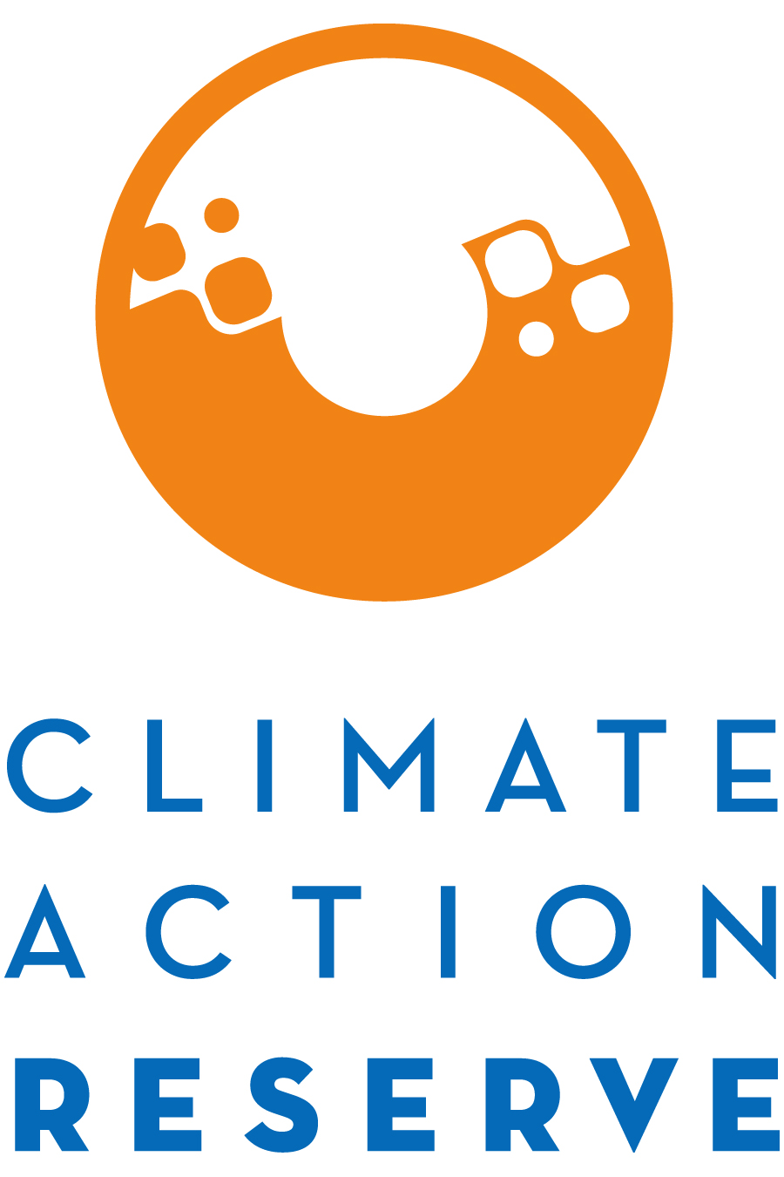

Participation in the Mexico Halocarbon Protocol Development Process

November 2020

Dear Interested Stakeholder,

The Climate Action Reserve (Reserve) is adapting and revising its Mexico Ozone Depleting Substances (ODS) Protocol Version 1.0 into a Mexico Halocarbon Protocol Version 1.0. This effort will focus on revising our existing protocol to include other potential halocarbons sourced in Mexico and destroyed at facilities in Mexico. For background on this project type, please see the materials available on the Mexico Ozone Depleting Substances Protocol webpage and the Mexico Halocarbon Protocol webpage.

The protocol will be developed through the Reserve’s transparent, stakeholder-driven process. Stakeholder involvement in this process will be a critical component of our success. Stakeholder workgroup meetings will take place primarily in Spanish and protocol drafts and other written materials will be available initially in English and translated to Spanish for workgroup and public comment; therefore, an ability to work in both Spanish and English is preferable.

You are invited to participate in the protocol development process by completing the attached form where you will express your interest and demonstrate your expertise to be part of a protocol workgroup.

The workgroup requires a participant’s commitment for the duration of protocol development, ideally some level of competence in greenhouse gas (GHG) accounting, and an advanced understanding of halocarbon applications and management systems, particularly in Mexico, and/or expertise in the development process of the Reserve’s Article 5 ODS Protocol and/or Mexico ODS Protocol. The workgroup members are expected to participate in 2-3 workgroup meetings (via webinar), and are responsible for helping to develop, comment on, and test early versions and sections of the protocol over the next 8 months, in addition to submitting written comments on both an initial draft protocol (February 2021) and a public comment draft protocol (March 2021).

Because of the technical nature of the work and a desire to reach consensus-based decisions, the protocol workgroup must be limited in size. We will strive to create a well-balanced workgroup with representation from industry, government, project developers, academia, verifiers, and environmental advocacy organizations across Mexico, potentially supplemented by U.S.-based stakeholders with extensive experience implementing the Reserve’s existing ODS protocols.

Please email the completed form to policy@climateactionreserve.org by close of business on Friday, December 4, 2020 in order to be considered for the workgroup. If you are not chosen to be a workgroup participant, we urge you to participate in the process as an observer, by submitting written comments on the protocol when it is available, and by attending the public webinar we will host during the public comment period.

Thank you for your interest. If you have any questions, please contact Beatriz Zavariz at bzavariz@climateactionreserve.org.
Mexico Halocarbon Protocol
Stakeholder Statement of Interest

Name:
Title:
Organization:
Email:
Phone:
Address:

Are you (or your organization) based in Mexico? Yes No

Briefly explain why you would like to participate as a workgroup member for the Mexico Halocarbon Protocol.

Areas of Expertise (select all that apply): |  |  | Expected Protocol Development Timeline
Greenhouse gas accounting |  |  | Workgroup formation | Nov – Dec 2020
Industrial refrigeration |  |  | Protocol drafting | Dec 2020 – Jan 2021
Industrial air condition |  |  | Workgroup meetings | Feb – Mar 2021
Residential refrigeration |  |  | Public comment period | Mar – Apr 2021
Halocarbon recovery |  |  | Protocol adoption | June 2021
Halocarbon recycling |  |  | Note: The Reserve anticipates that the protocol development workgroup responsibilities will adhere to the timeline above. However, specific protocol development priorities are subject to change pending outcomes of the drafting and public comment processes.
Halocarbon destruction
CAR U.S., A5, or MX ODS Protocols
Other relevant area (please specify)

Justify why you should be included in the workgroup and how the process would benefit from your participation. Include relevant experience and expertise.

Specifically, explain your level of expertise and relevant experience with the recovery, recycling, and/or destruction of halocarbons. Please highlight your Mexico-specific expertise.

Explain your level of expertise and relevant experience with GHG accounting and projects destroying halocarbons in Mexico, the U.S., and/or Article 5 countries. If you lack expertise specific to Mexico, please address why you should still be included in the workgroup and how the process would benefit from your participation.

How many hours per week can you commit to this process from February to May 2021?
hours/week

Please indicate your language proficiency levels:
English | Spanish
Elementary | Elementary
Limited working | Limited working
Minimum professional | Minimum professional
Full professional | Full professional
Native or bilingual | Native or bilingual

