My Invoices Report – Registry Update
The Reserve updated the registry’s My Invoices report in December 2020. Account Holders may access their invoices in the same manner as before and invoices continue to be downloadable from the registry. Please see guidance on the updated interface below, and reach out to reserve@climateactionreserve.org with any questions.

New Interface
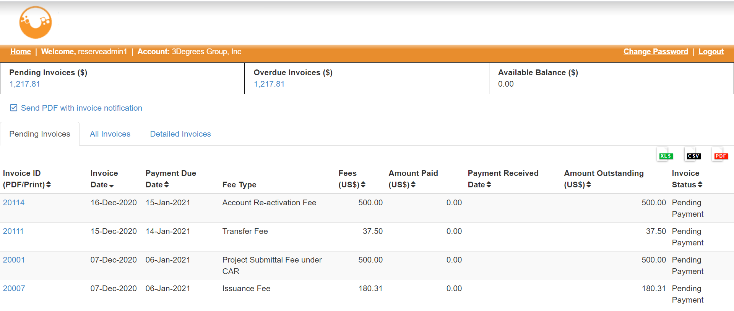
Figure 1. My Invoices Report Updated Interface
Invoices are downloadable by clicking on the invoice ID to the far left. The Pending Invoices tab lists all pending invoices. The All Invoices tab lists all invoices including those that are pending, have been completed, or have been cancelled. The Detailed Invoices tab includes all invoices and includes the description and unit quantity that is included on the invoice. Account holders may also select to have the invoice PDF be included with the invoice notification email. All accounts default with this option selected.

Holding a Balance
Account holders may choose to hold a balance in their account so that they may apply the balance to future invoices. If an account holder wishes to do so, please send payment by wire/ACH or check to APX, Inc., and send a notification to reserve@climateactionreserve.org with information on the incoming payment, including the account to which it should apply.
If an account holder wishes to apply their available balance to a pending invoice, in the My Invoices Report, click “Apply balance to invoices” under Available Balance.
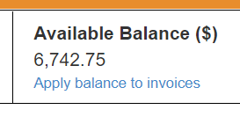
Figure 2. Detail of “Apply Balance to Invoices” Link
Select the invoice(s) to which the balance will apply, then click “OK.” Once the request is submitted, APX will apply payment to the selected invoice(s) within 24 hours.
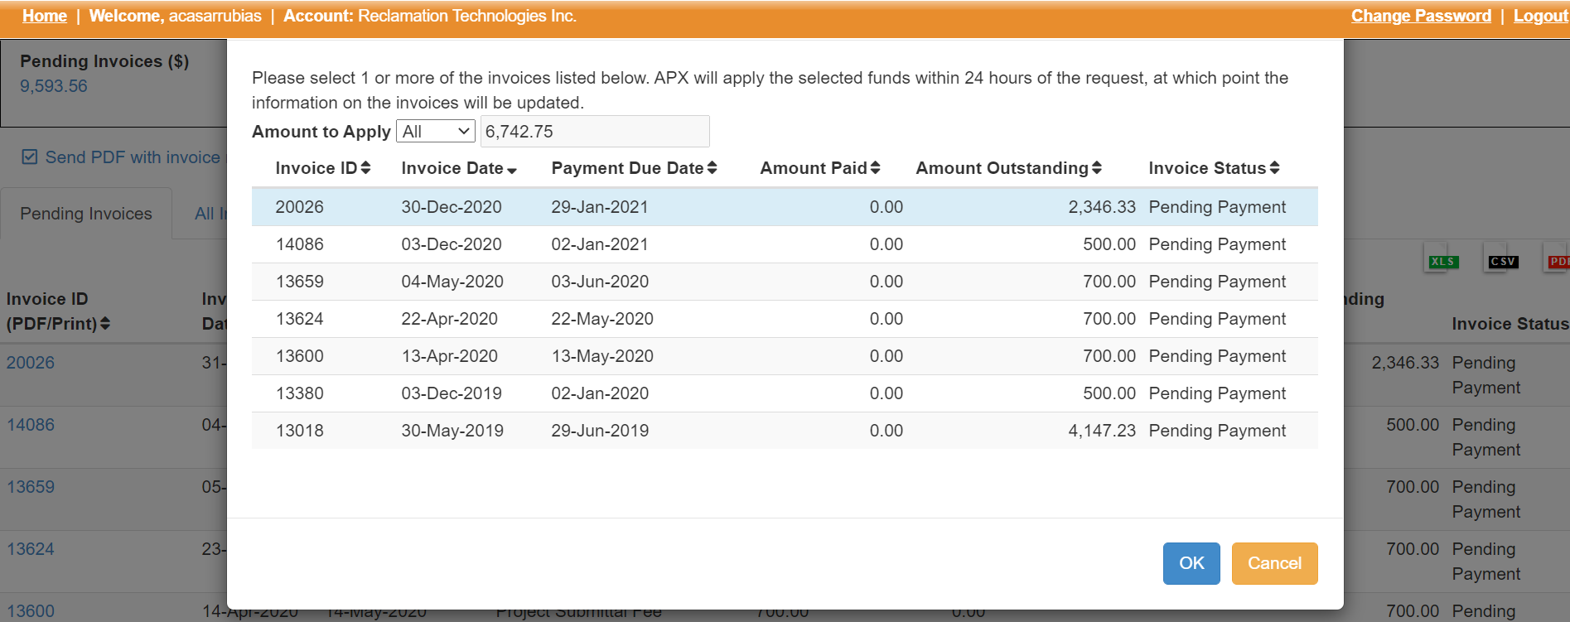
Figure 3. Apply Balance to Invoices Screen

Additional Information to Add to Invoices
Account holders may choose to add any of the following information to their invoices or billing information:
- Purchase Order Number
- Customer Number
- Additional billing emails
If at any point this information needs to be added or updated, please send an email to reserve@climateactionreserve.org with the details of the request and Reserve staff will update the appropriate information.

