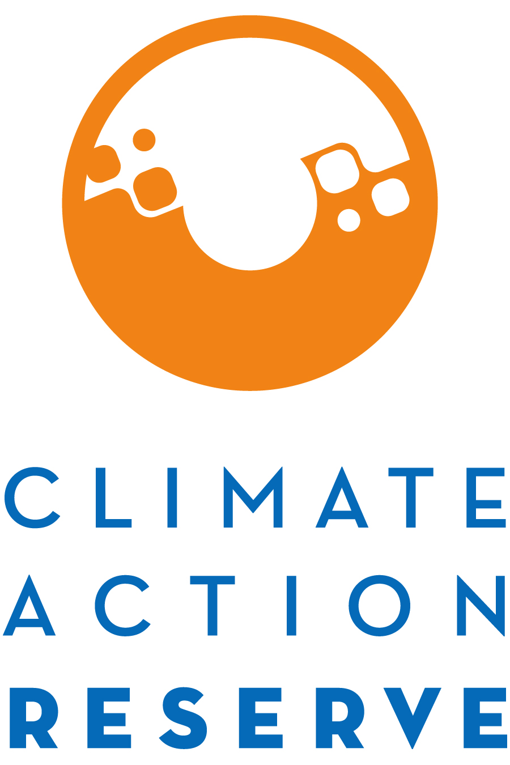

Participation in the Mexico Forest Protocol Revision Process

September 2021

The Climate Action Reserve (Reserve) is updating the Mexico Forest Protocol (MFP) from Version 2.0 to Version 3.0. This effort will center in the revision of mechanisms to comply with the permanence and additionality requirements, the application of stratification for forest inventories, modifications for mangrove ecosystems such as the inclusion of soil carbon, and social safeguards, among other topics. For further information on the protocol, please consult the Mexico Forest Protocol website.

The protocol will be developed through the Reserve’s transparent, stakeholder-driven process. Your involvement in this process will be a critical component of our success.

The working language is expected to be primarily Spanish, but some issues may need to be discussed in English and Spanish to incorporate the participation of specific experts. For workgroup meetings, we will explore other options such as simultaneous translation, providing slides in both languages, and/or holding meetings in both languages.

You are invited to participate in this process by completing the attached form, where you will express your interest and experience in the forest sector.

The workgroup requires a significant time commitment and an advanced understanding of GHG accounting, land tenure, forestry, and forest carbon sequestration issues, ideally in Mexico. The workgroup members are responsible for helping to develop, comment on, and examine early versions and sections of the protocol, in addition to submitting written comments on both the draft and final protocol.

Because of the technical nature of the work and a desire to reach consensus-based decisions, the protocol workgroup must be limited in size. We will strive to create a well-balanced workgroup with representation from industry, government, project developers, academia, verifiers, and environmental advocacy organizations across Mexico.

Please email the completed form to policy@climateactionreserve.org no later than Thursday, September 30, 2021 in order to be considered for the workgroup.

If you are not chosen to be a workgroup participant, we urge you to participate in the process as an “observer” by attending workgroup meetings in listen-only mode, submitting written comments on the protocol when it is available for public comment, and attending public webinars we will host throughout the protocol development process.

Thank you for your interest. If you have any questions, please feel free to contact Amy Kessler at akessler@climateactionreserve.org.
Statement of Interest Form
Mexico Forest Protocol Stakeholder Participation

Name:
Title:
Organization:
Email:
Phone:
Address:

Are you or your organization based in Mexico?

Briefly explain why you would like to participate as a workgroup member for the Mexico Forest Protocol.

Experience (select all that apply):
Greenhouse gas accounting
Land tenure
Agrarian rights (Agrarian Law)
Forest inventories
Forest project development in Mexico
Development of projects in mangrove forests
Soil carbon quantification (ideally within mangrove forests)
Social structures in Mexico and/or social safeguards
Other (please explain)

Briefly justify why you should be included in the workgroup and how the process would benefit from your participation. Include relevant experience and expertise.

Explain your level of experience with the forestry sector in Mexico.

Explain your level of experience with GHG accounting in the forest sector.

Explain your knowledge of social or agrarian issues related to forestry activities in Mexico.

How many hours per week can you commit to this process? This is an average, it will not be necessary to commit time each week.
hours/week

Please select your comprehension level of the following languages:
English | Spanish
None | None
Limited | Limited
Professional | Professional
Native or bilingual | Native or bilingual

Timeline for Protocol Development
Workgroup formation | September 2021
Workgroup meetings | October – December 2021
Protocol development | December 2021 – February 2022
Public comment period | March 2022
Protocol presented to Reserve Board for adoption | June 2022
Note: The Reserve anticipates that the project will align to the timelines described above. However, times may change due to changes in protocol development priorities based on the results of the development process and the public consultation process.

