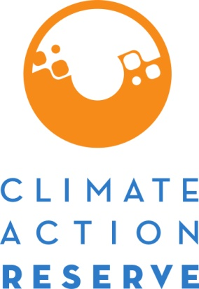
Request for Project Verification Deadline Extension
November 2020
The Climate Action Reserve (Reserve) may grant an extension to a project’s verification deadline upon submission of this form and payment of a $200 fee. For initial reporting periods, the verification deadline for non-forest projects is twelve (12) months after the end of the initial reporting period, and the deadline for forest and urban forest projects is thirty (30) months after the project is submitted. For subsequent reporting periods, a project’s verification deadline is twelve (12) months after the end of the reporting period. No extension request will be granted unless the project has commenced verification and has undergone a site visit for the reporting period (or has submitted data to the verification body in the event of a desk review verification) and all outstanding invoices for the project and account holder have been paid. The following extensions may be granted:

- Forest (U.S. and Mexico), grassland (U.S. and Canada), and urban forest projects may
be granted a 12-month extension.
- Livestock (U.S. and Mexico), landfill (U.S. and Mexico), and nitrogen management
projects may be granted a six-month extension.
- All other project types may be granted a 30-day extension if the account holder can
demonstrate to the Reserve’s satisfaction that they will miss the deadline due to
extraordinary circumstances. The Reserve holds the right to determine what rises to the
level of an extraordinary circumstance.

Only with explicit, written approval of the request may an account holder submit a project for registration after the verification deadline has passed. The Reserve retains the right to (1) reject any Request for Project Verification Extension that does not comply with these requirements, (2) request further documentation, and/or (3) impose additional constraints. If the Reserve accepts this extension request, a letter stating the new project verification deadline will be sent to the account holder, and will be made publicly available. A maximum of one extension may be granted per project. Extension requests must be received prior to the project’s verification deadline. If denied or received after this verification deadline, the project must apply for a Zero-Credit Reporting Period or be re-submitted for registration under the most current version of its associated protocol.

Instructions
- Complete the Request for Project Verification Deadline Extension form and email the completed form and requested documentation to reserve@climateactionreserve.org
- An invoice for the review fee ($200 per request) will be emailed directly to you.
- Pay the review fee (instructions for payment are located on the invoice).
- The review will commence upon completion of steps 1-3.

Project Details

Date of Request:

Account Holder:

Project ID Number (e.g. CAR100) or Cooperative/Aggregate ID Number:

Project Type:

Protocol Version Used:

Reporting Period (for which request applies to): to

Form Completed By (name and email):

- If reporting period is being verified with a site visit, has a site visit occurred?
Yes, Date(s): No N/A

- If reporting period is being verified with a desk review verification, has required project data and documentation been submitted to the verification body?
Yes, Date(s): No N/A

- Reason for Extension: provide a detailed description of any issues that are contributing to the delay in meeting the deadline.

- Provide documentation to confirm a site visit for the project has occurred (e.g., List of Findings reflecting site visit activity, draft Verification Report, plane tickets, travel receipts, etc.) or – for desk review verifications and project types that do not require site visits - to confirm project documentation and data has been submitted (e.g., email correspondence, “Dropbox,” ftp, etc.).

The $200 fee applies on a per-request basis. For aggregated projects or projects in a cooperative, one request may be submitted to cover the entire aggregate or cooperative.

