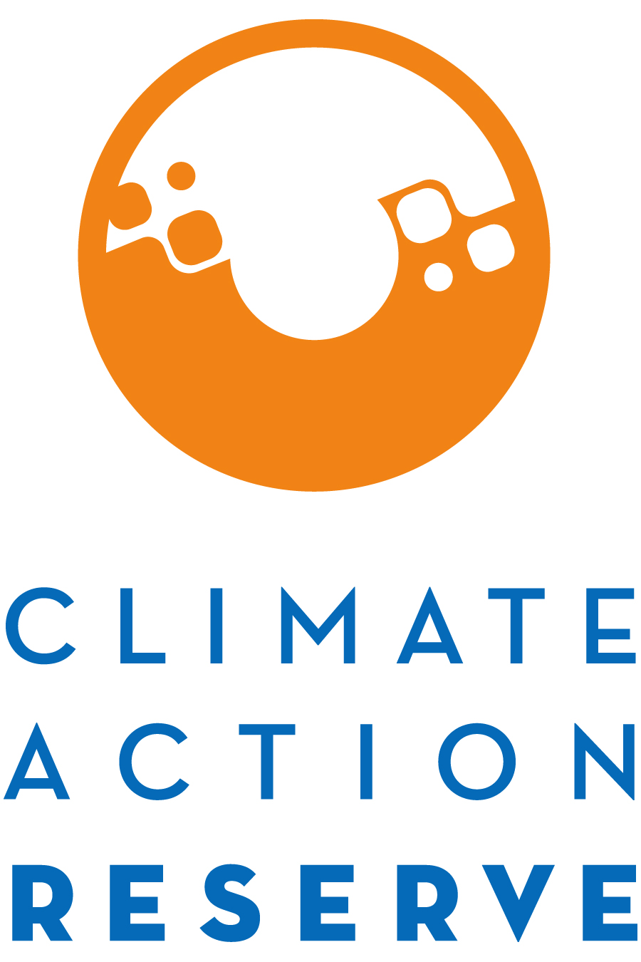

Invitation to Participate in the Low Carbon Protocol Development Process

October 14, 2022

The Climate Action Reserve (Reserve) is developing a greenhouse gas (GHG) project protocol for the reduction of CO₂ at cement production facilities. The Low Carbon Cement Protocol will provide a standardized approach for how to quantify, monitor, report, and verify the climate benefits associated with the alternative use of supplementary cementitious materials (SCMs) to produce cement.

This project protocol will be developed through the Reserve’s transparent, stakeholder-driven process. Your involvement in this process will be a critical component of our success.

You are invited to participate in this process by completing the attached form, where you will express your interest and demonstrate your expertise to be part of the protocol workgroup.

The workgroup requires a significant time commitment, an advanced understanding of GHG accounting, and a comprehensive understanding of cement and or SCM production. The workgroup members are responsible for helping to develop, comment on, and test early versions and sections of the protocol over the next few months, in addition to submitting written comments on both the workgroup draft protocol (November/December 2022) and public draft protocol (January 2023).

Because of the technical nature of the work and a desire to reach consensus-based decisions, the protocol workgroup must be limited in size. We will strive to create a well-balanced workgroup with representation from industry, government, project developers, academia, verifiers, and environmental advocacy organizations.

Please email the completed form to policy@climateactionreserve.org by Friday November 18, 2022, in order to be considered for the workgroup.

If you are not chosen to be a workgroup participant, we urge you to participate in the process as an “observer” by attending workgroup meetings in listen-only mode, submitting written comments on the protocol when it is available for public comment in January 2023, and attending the public webinar we will host during the public comment period.

Thank you for your interest. If you have any questions, please feel free to contact McKenzie Smith at msmith@climateactionreserve.org or (213) 542 – 0282.

Low Carbon Cement Protocol Stakeholder Statement of Interest (SOI) Form
Areas of expertise (select all that apply):

Greenhouse gas accounting
Cement industry
Slag industry
Concrete industry
Natural Pozzolan industry
Other (please specify)

Current sector:

Project proponent/developer
Verifier
Carbon broker
Industry consultant
Government Industry
NGO
Environmental group
Academia
Other (please specify)

Name:
Title:
Organization:
Email:
Phone:
Address:

How many hours per week can you commit to this process from November 2022 – January 2023?
hours/week

How is your organization involved with cement and/or supplementary cementitious material (SCM) production?

What technical skills/experience could you offer to the workgroup process?

What regulatory and policy experience in the realm of cement or SCM production could you offer to the workgroup process?

Briefly explain why you would like to participate as a workgroup member for the Low-Carbon Cement Protocol.

Justify why you should be included in the workgroup and how the process would benefit from your participation. Include relevant experience and expertise.

