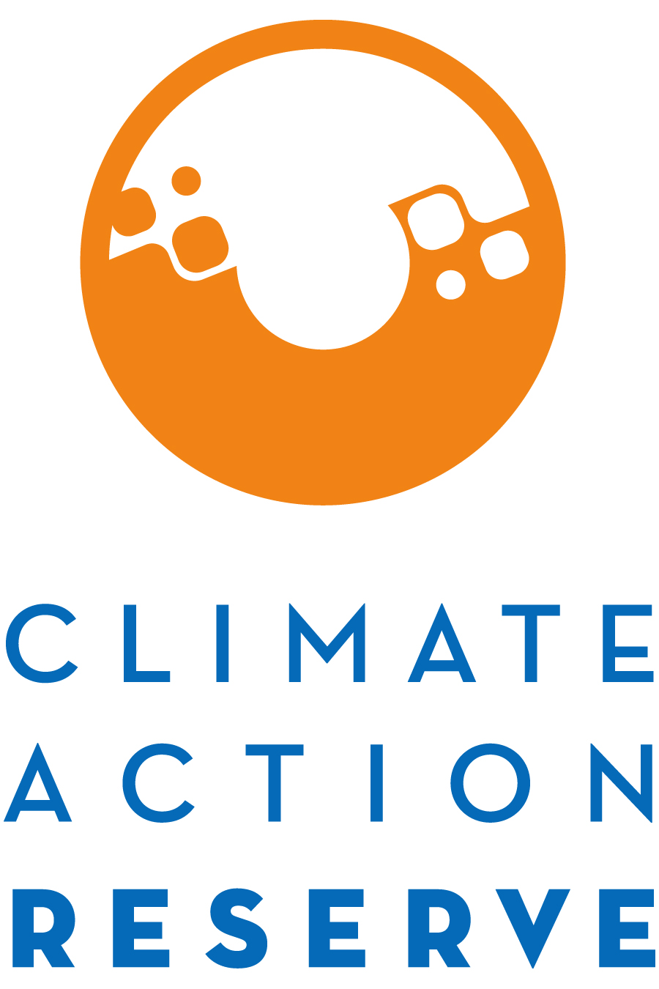

Invitation to Participate in the China Adipic Acid Production Protocol Development Process

January 30, 2023

The Climate Action Reserve (Reserve) is developing a protocol to account for, report, and verify the greenhouse gas emission reductions associated with the installation and use of a nitrous oxide (N₂O) emission control technology at adipic acid production facilities in China. The China Adipic Acid Production Protocol will provide a standardized approach for how to quantify, monitor, report, and verify N₂O emission reductions at adipic acid production facilities.

This project protocol will be developed through the Reserve’s transparent, stakeholder-driven process. Your involvement in this process will be a critical component of our success.

You are invited to participate in this process by completing the attached form, where you will express your interest and demonstrate your expertise to be part of the protocol workgroup.

The workgroup requires a significant time commitment, an advanced understanding of GHG accounting, and/or a comprehensive understanding of the adipic acid production industry. The workgroup members are responsible for helping to develop, comment on, and test early versions and sections of the protocol over the next few months, in addition to submitting written comments on both the workgroup draft protocol and public draft protocol.

Because of the technical nature of the work and a desire to reach consensus-based decisions, the protocol workgroup must be limited in size. We will strive to create a well-balanced workgroup with representation from industry, government, project developers, academia, verifiers, and environmental advocacy organizations.

Please email the completed form to rmooney@climateactionreserve.org by March 17, 2023, in order to be considered for the workgroup.

If you are not chosen to be a workgroup participant, we urge you to participate in the process as an “observer” by attending workgroup meetings in listen-only mode, submitting written comments on the protocol when it is available for public comment in Spring 2023, and attending the public webinar we will host during the public comment period.

Thank you for your interest. If you have any questions, please feel free to contact Rachel Mooney (rmooney@climateactionreserve.org).

Adipic Acid Production Protocol Stakeholder Statement of Interest (SOI) Form
Areas of expertise (select all that apply):

Greenhouse gas accounting
Adipic Acid Production industry
Abatement technology
Other (please specify) :

Current sector:

Project proponent/developer
Verifier
Carbon broker
Industry consultant
Government Industry
Non-Government Organization
Environmental group
Academia
Other (please specify)

Name:
Title:
Organization:
Email:
Phone:
Address:
Language Preference:

How many hours per week can you commit to this process from March 2023 – June 2023?
hours/week

How is your organization involved in the adipic acid production industry?

What technical skills/experience could you offer to the workgroup process?

What regulatory and policy experience in the realm of adipic acid production could you offer to the workgroup process?

Briefly explain why you would like to participate as a workgroup member for the China Adipic Acid Production Protocol.

Justify why you should be included in the workgroup and how the process would benefit from your participation. Include relevant experience and expertise.

